***Index***

|  |  |
| --- | --- |
| **Topic** | **Page number** |
| Introduction | 1 |
| Material provided in the toolkit | 3 |
| Circuit Diagram | 4 |
| Steps to build | 5 |
|  |  |

**Introduction**

**What is a space rover?**

A rover (or sometimes planetary rover) is a planetary surface exploration device designed to have been designed as land vehicles to transport members of a human spaceflight crew; others have been partially or fully autonomous robots. Rovers are typically created to land on another planet (other than Earth) via a lander-style spacecraft, tasked to collect information about the terrain, and to take crust samples such as dust, soil, rocks, and even liquids. They are essential tools in space exploration. They arrive on spacecraft and are used in conditions very distinct from those on the Earth, which makes some demands on their design. Rovers also have to withstand high levels of acceleration, high and low temperatures, pressure, dust, corrosion, cosmic rays, remaining functional without repair for a needed period of time.

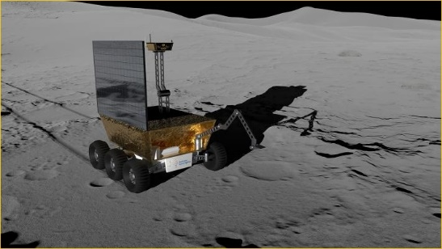



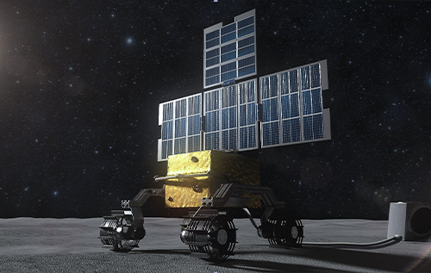

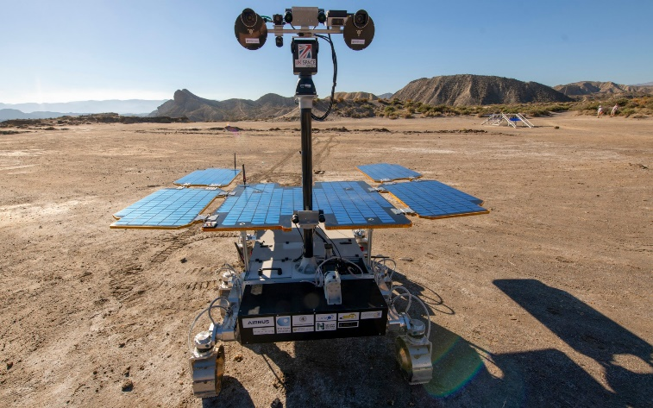

**Why are space rovers important?**

Rovers help scientists in their quest to understand what different parts of the planet are made of. Different planets are made up of lots of different types of rocks, and each rock is made up of a mixture of chemicals. A rover can drive around to different areas, studying the different chemicals in each rock. These chemicals can tell scientists something about the environments that changed that rock over time. The rovers rolled out to take panoramic images. These images gave scientists the information they needed to select promising geological targets to explore. Then, the rovers drove to those locations and beyond to perform close-up scientific investigations.

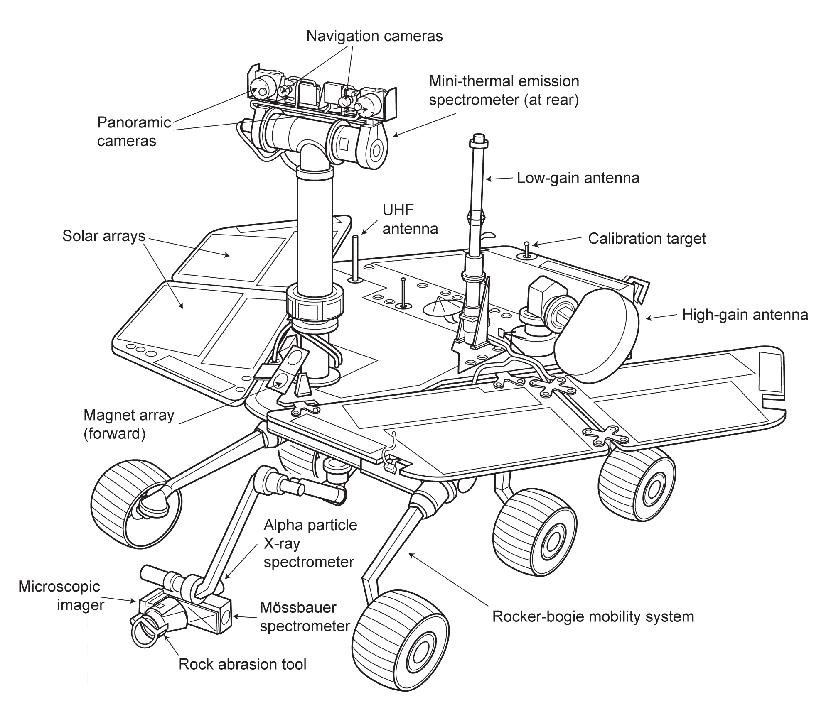**A diagram showing the components of a real life space rover:**

**Material provided in the toolkit for the space rover model**

* L298N Motor Driver [Rover controller]
* BO Motor Wheels X4
* 2s,7.4 v,1000mah,30C Li-po Battery
* Jumper Wires (ESP-Motor, SERVO, Motor and Motor Power)
* Solar panel
* Camera X2
* Baseplate
* M3 Screws and Nuts
* Screwdriver
* Battery Tray
* ESP 32 CAM
* ESP PCB
* CAM SERVO
* Screwdriver

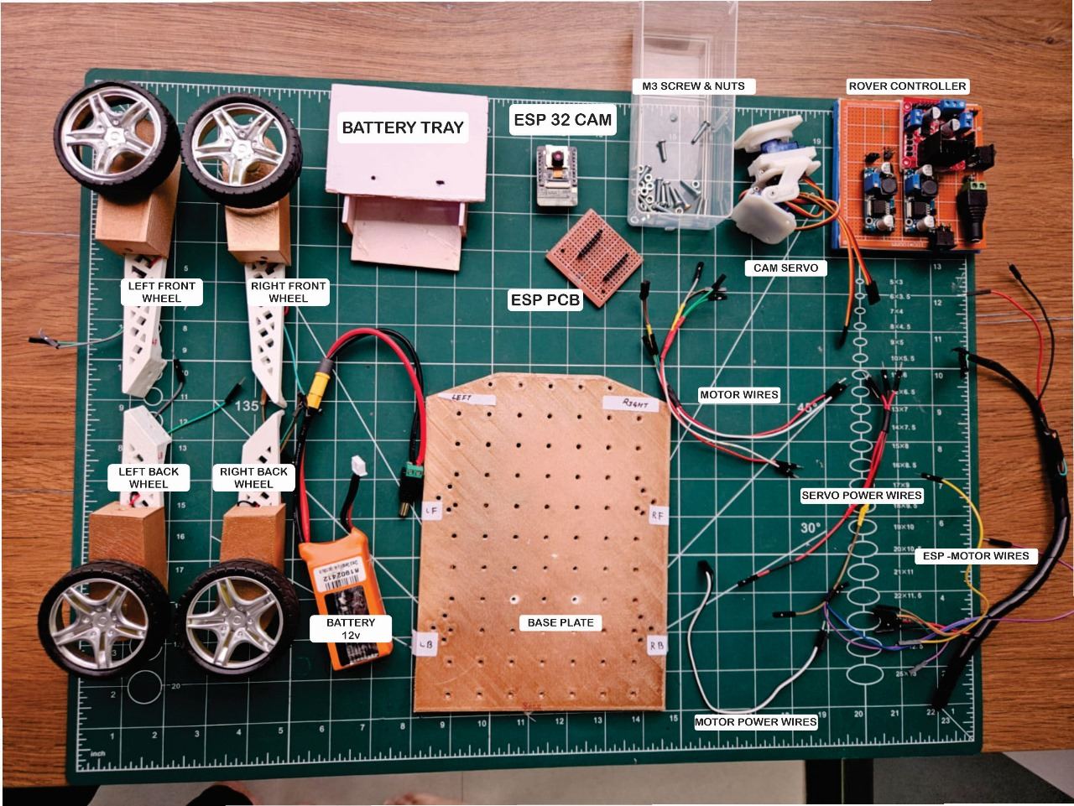

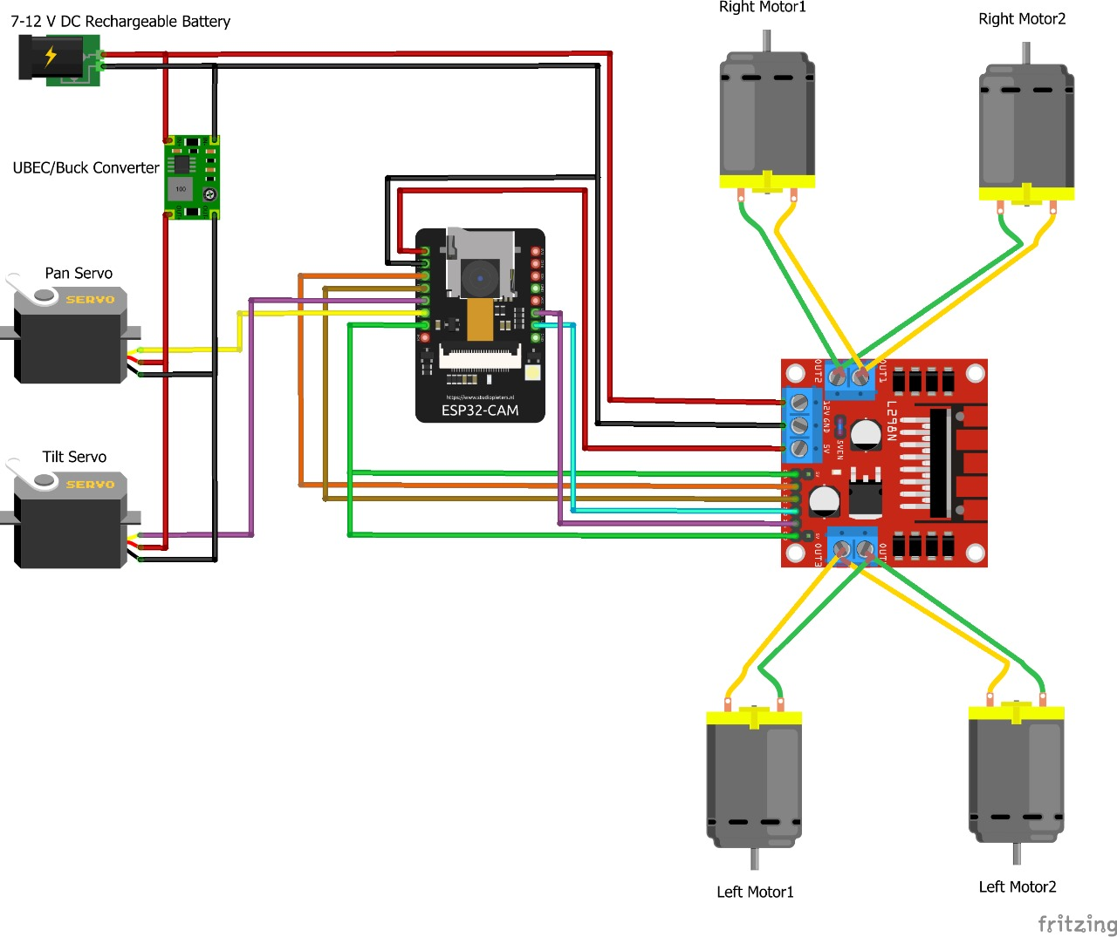**Circuit diagram**

**Steps to build**

* **Prepare Your Workspace:**

1. **Find a clean, well-lit workspace with enough room to spread out your components and tools.**
2. **Ensure you have access to power outlets for testing and assembly.**

* **Organize Components:**

1. **Lay out all the components on your workspace, ensuring you have everything listed in your inventory.**
2. **Group similar components together for easy access during assembly.**

* **Mount Motors onto Baseplates:**

1. **Take the baseplate and mount one wheel on the RF side**
2. **Use the M3 screws and nuts to securely attach the wheel to the baseplate.**
3. **Repeat this process for the other wheels on the LF, LB, RB sides.**

* **Connect the ESP 32 CAM:**

1. **Take the ESP PCB and ESP 32 CAM; join the pins of the ESP 32 CAM on the ESP PCB.**
2. **Make sure that the camera on the ESP 32 CAM is facing upwards.**
3. **Take the ESP-Motor wires and follow the wire connections from the circuit diagram given.**

* **Make the Motor connections:**

1. **Take the Motor Wires and make the connections to the motor by following the circuit diagram.**
2. **Repeat it for the other side.**

* **Attach the Rover Controller:**

1. **Take the Rover Controller; peel of the sticker behind.**
2. **Position the Rover Controller at the back of the baseplate between LB and RB (just on top of the battery tray) then gently stick it.**
3. **Make the necessary connections using the circuit diagram. (Screwdriver will be required)**

* **Mount the CAM SERVO:**

1. **Take the CAM SERVO; position the CAM SERVO’s front side (the rounded rectangular side which contains wires) to be on top.**
2. **Place the underside of the CAM SERVO’s base at the front of the baseplate in between the RF and LF.**
3. **Use the M3 screws and nuts to securely attach the CAM SERVO’s underside to the baseplate.**
4. **Make the connections with the SERVO Power wires using circuit diagram.**

* **Final Adjustments:**

1. **Take the battery and place it inside the Battery Tray.**
2. **Make sure all the steps and connections are done correctly.**
3. **Connect the DC connector of the battery to the female DC connector in the remote controller, then finally turn on the switch!**

**All steps are completed!**

**Scan the QR code for more info!**